The Harbor Ridge Homeowner
A Publication of the Harbor Ridge Homeowners Association WINTER 2010
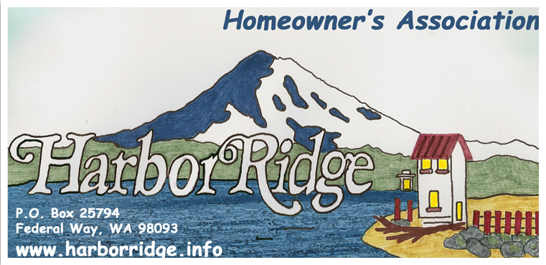

The 2010 Annual Meeting will be at Resurrection Lutheran Church,
on the corner of Ridge Drive and Brown’s Pt. Blvd.,
Sunday, January 17th, at 3:00 p.m.
All Harbor Ridge homeowners are invited to participate.
This Newsletter serves as the announcement for the meeting.

AGENDA:
- INTRODUCTIONS
- RE-CAP OF 2009
- PLANS FOR 2010
- ELECTION OF BOARD MEMBERS
- SOCIAL TIME

Thank you – for all who have made the effort to keep their homes and yards in such excellent condition. There was no way to single out any one home because almost everyone is doing so much to maintain their homes. This is particularly appreciated in view of the challenging financial time period we are experiencing as a nation.

Dues for 2010 – Please bring your $35 annual dues payment to the annual meeting, or mail to:

Harbor Ridge Homeowners Association
P.O. Box 25794
Federal Way WA 98093 – 2794

Your Homeowners Association

What is a homeowner’s association to you? A nosey group of busybodies! A group of neighbors trying to keep a community nice and reasonably clean!

The primary responsibility of our homeowner association is to maintain community entrances, preserve the quality of your neighborhood and the value of your home, act as a neutral third party to resolve differences between neighbors, and to promote awareness and maintenance of the codes, covenants, and restrictions for the development. All of these things require an involvement by us, the residents. It is the mutual sense of responsibility that allows this to continue to be a great place to live.

The current board is striving to find and respond to the community needs. One of those ways is having the HRHA website (www.harborridge.info/). The site is an information resource and a communication portal. The association has also co-hosted National Night Out events with Resurrection Lutheran Church.

Without your feedback, it will all be for nothing. If you have a concern, please contact the board and allow us to help in any way we can. Your continuing support of the homeowner dues is greatly appreciated as it is these funds that allow us to continue the services and resources that are currently available. The board is always willing to hear ideas for more efficient and productive resources and programs of community involvement.

“Be Green” Option: Members can provide us with their email addresses if they would like to have the periodic Newsletters sent to them by email, rather than mailed or delivered to their doorstep. This would save us printing and mailing costs as well. We have a small list right now but would love to email to many more. Please visit the website (www.harborridge.info/) and send us an email.

Need Help in the Yard? The Association has hired a man to help with key aspects of maintaining the entrances, including the irrigation systems. His name is Jose Armenta and we have been pleased with his work and work ethic. Jose has also been hired by many of the individual homeowners in Harbor Ridge who have, to the best of our knowledge, also been satisfied with his work and his hourly rate. If you have an interest in talking to Jose about any yard work (sprinkler installation, winter pruning, pressure washing, lawn maintenance, weeding, installation of pathways, etc.) or irrigation work, he can be reached at (253) 301-9510.

